Event Planning using ChatGPT
Source | Innovation
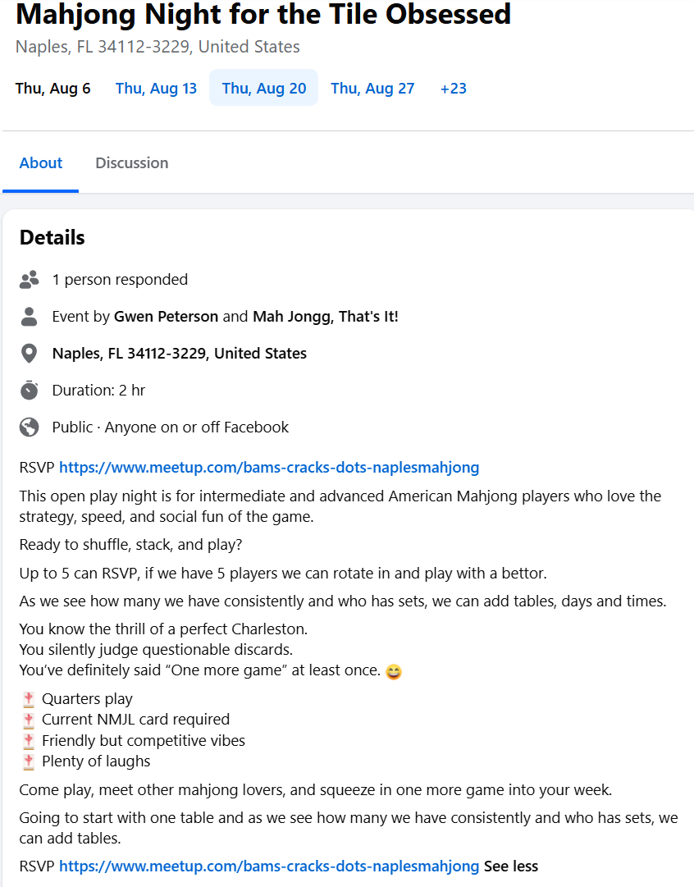 | Event Title: Tile Obsessed: A Mah Jongg Show & Play Event  Event Description: A night for experienced players who love the tiles almost as much as they love the game!  Bring your favorite themed mah jongg set and tablescape to show off, share, and—most importantly—play with. Don’t have a themed set? Don’t let that stop you! Come discover some of the creative, colorful, and downright irresistible sets other players bring to the tables.  Bring an appetizer to share.  Come ready to admire, discover, and play!

ChatGPT Activity
INPUT: I found an event by an instructor called "Mah jongg Night for the Tile Obsessed" This is a casual group of experienced players which is not quite what I expected, because of the use of the word Tile. I thought it was going to be an event focused on the Mahjong sets, not just playing the game. SO, I would like to create an event that I anticipated - I want people to bring their favorite themed set to play with so we can make it more about the tile obsession. Let's brainstorm an event title similar to the event I found using the words "tile obsessed."
ChatGPT: Yes—your instinct is right. “Tile Obsessed” promises something more than ordinary game night. It suggests the stuff of mah jongg: the sets, artwork, colors, materials, themes, accessories, and the stories behind what people own. If the event is simply experienced players gathering to play, the phrase is doing more work than the concept.
For your version, I’d deliberately lean into the obsession. Everyone brings a favorite, unusual, beautiful, vintage, themed, or conversation-starting set, and the sets themselves become part of the experience.

Here are some title directions:
- A Night for the Tile Obsessed
- Game Night for the Tile Obsessed
- Play Night for the Tile Obsessed
- Tile Obsessed: A Mah Jongg Show & Play
- Tile Obsessed: Bring Your Favorite Set
- Tile Obsessed: Show, Share & Play
- Tile Obsessed: Sets on the Table
- Tile Obsessed: The Sets We Love
- Tile Obsessed: A Celebration of Mah Jongg Sets
- For the Tile Obsessed: Bring Your Best Set
- For the Tile Obsessed: Mah Jongg Set Showcase & Play
- The Tile Obsessed Social
- The Tile Obsessed Game Night
- The Tile Obsessed Set Social
- Calling All Tile-Obsessed Players
My favorite is Tile Obsessed: Show, Share & Play. It immediately distinguishes your event from an ordinary game night. “Show” gives people permission to bring something special, “share” creates conversation and storytelling, and “play” keeps mah jongg at the center.
But there’s another direction I think fits your concept especially well:
A Night for the Tile Obsessed
Bring the set you love to show off.
That feels like an event rather than a class or structured showcase. You could have people rotate tables so they actually get to experience several different sets rather than bringing a beautiful set that only four people ever touch.
And there is a bigger opportunity here: the sets could be the stars rather than merely the equipment. You could invite people to give their set a little “story card”—where it came from, why they chose it, what makes it special—and have playful recognition such as Most Unexpected, Best Theme, Most Coveted, Best Story, or Set Everyone Wants to Play Next. That would make “Tile Obsessed” genuinely mean something.
INPUT: I like "Tile Obsessed: A Mah Jongg Show & Play Event"
This would be a 4-hour event
5-9 PM with an appetizer potluck
Create a player-facing value proposition
ChatGPT: I’d position the value around showing, discovering, connecting, and playing—because the differentiator isn’t simply playing mah jongg for four hours. It’s getting to bring out those special sets that players love to own and talk about.
Player-Facing Value Proposition
Tile Obsessed: A Mah Jongg Show & Play Event is a night for players who love the tiles almost as much as they love the game. Bring a favorite themed, unique, or simply irresistible mah jongg set to show off, share its story, and put it into play.
Spend the evening discovering sets you may have never seen before, playing with different tiles, connecting with other tile enthusiasts, and enjoying an appetizer potluck along the way. It’s part game night, part show-and-tell, and entirely for the tile-obsessed.
Bring a set. Bring an appetizer. Come ready to admire, share, and play.

