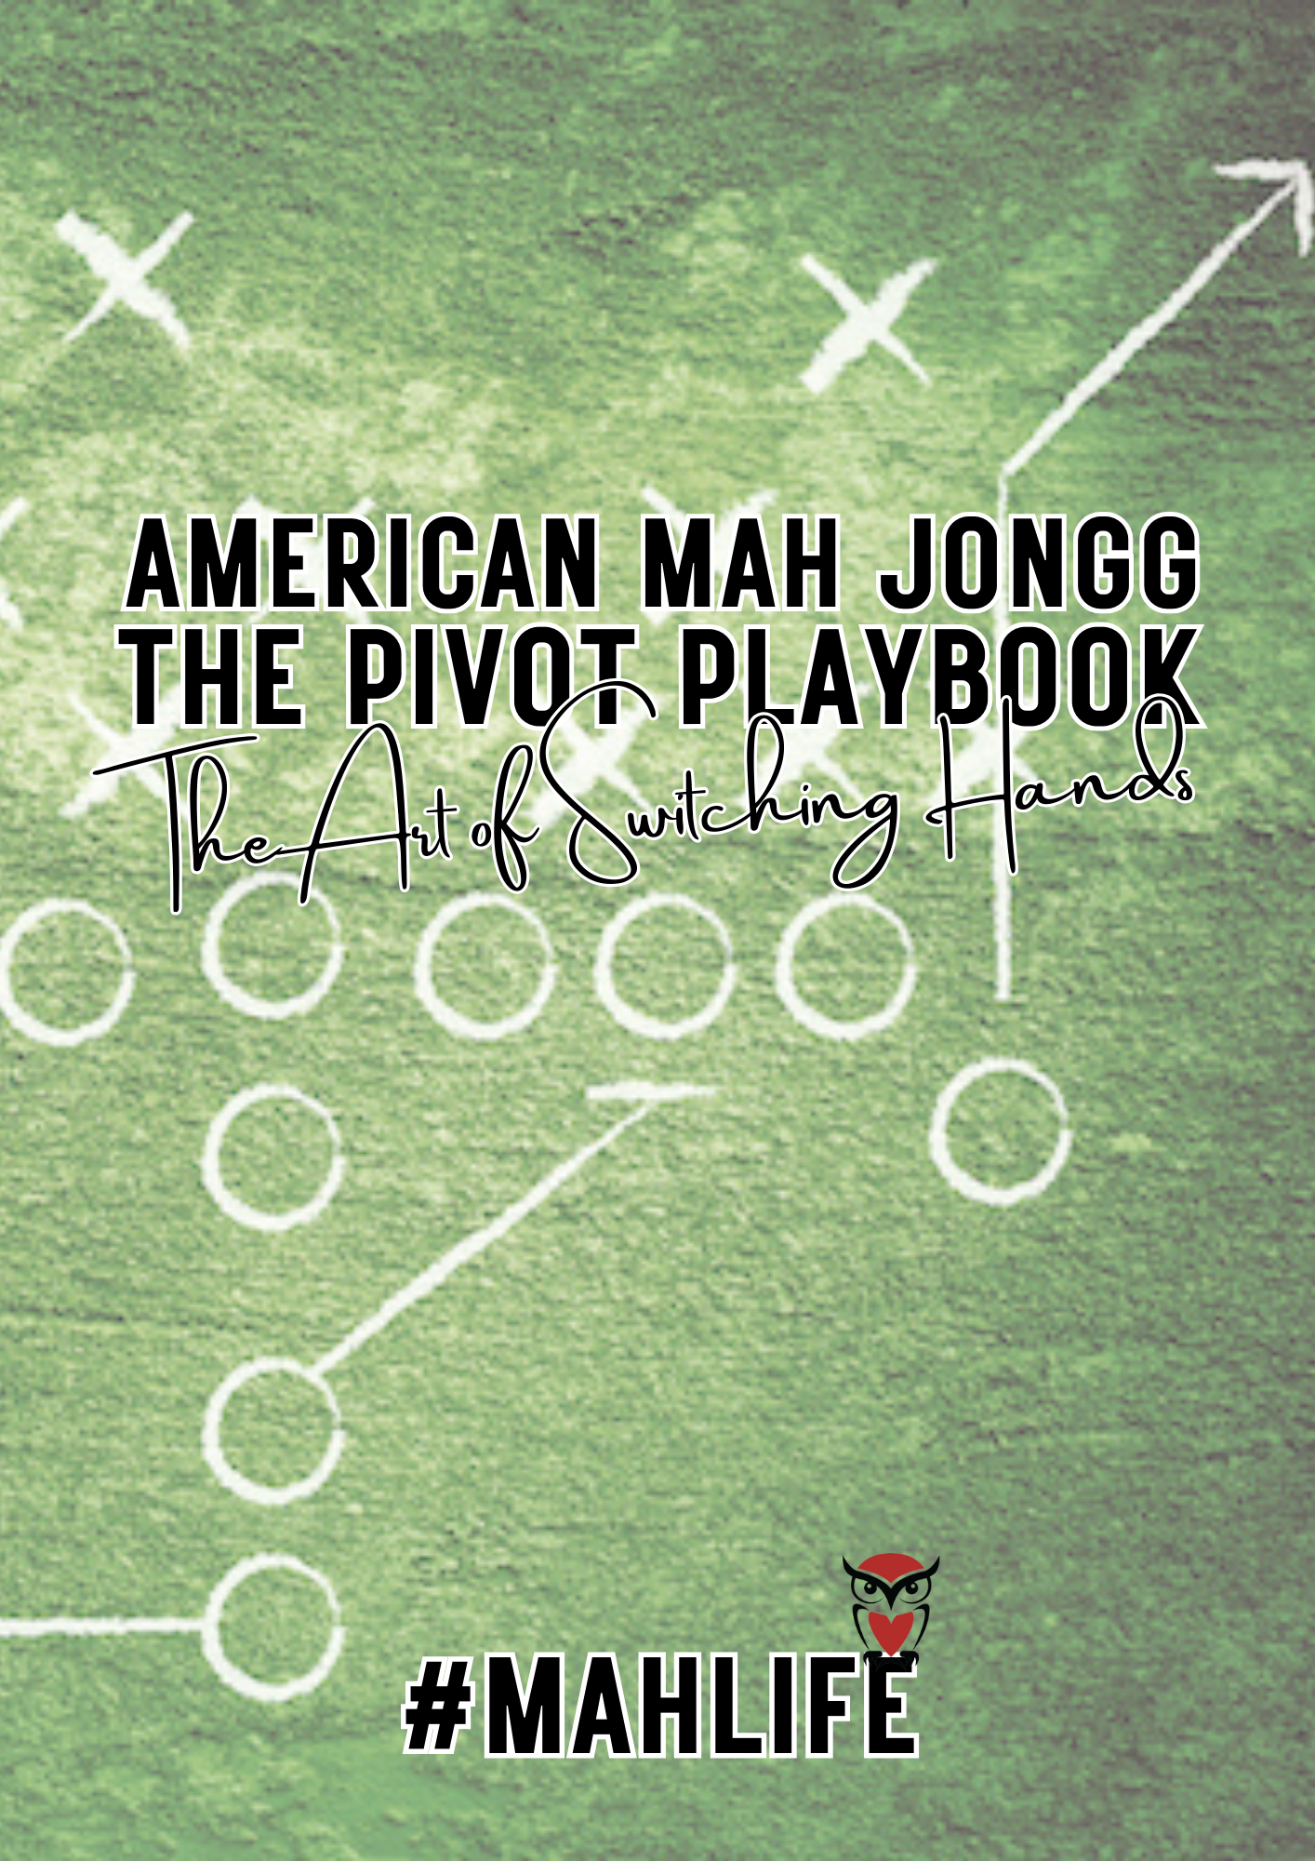
Intended to be used digitally

2026 Michele Frizzell / Mahj Life®
All rights reserved, except as outlined under the following Creative Commons license.
This work is licensed under a
Creative Commons Attribution-NonCommercial-ShareAlike 4.0 International License.
To view a copy of this license, visit https://creativecommons.org/licenses/by-nc-sa/4.0/
You are free to:
- Share — copy and redistribute the material in any medium or format
- Adapt — remix, transform, and build upon the material
Under the following terms:
- Attribution — You must give appropriate credit, provide a link to the license, and indicate if changes were made.
- NonCommercial — You may not use the material for commercial purposes.
- ShareAlike — If you remix, transform, or build upon the material, you must distribute your contributions under the same license as the original.
This facilitator playbook is intended as a practical guide for hosting local meetups. It is designed to support community-building, collaboration, and professional growth within the Mahj Life® Instructor Guild.
For additional permissions or questions, contact: michele@mahjlife.com
Website: https://mahjlife.com
Mahj Life® and the Mahj Life logo are registered trademarks.

The Pivot Challenge
The Pivot Challenge uses four deliberate pivot points to give players structured practice making pivot decisions under different conditions. Each point represents a common moment where players feel pressure to change course—and where judgment, not habit, should guide the decision.

Pivot Points & Why They Matter
Pivot Point 1 After the First Left in the Charleston
This point introduces early pivot thinking without commitment. Players practice recognizing when hand development stalls before too many tiles are invested. It helps students notice stagnation without reacting prematurely or chasing flexibility too soon.
Pivot Point 2 After the Charleston
A lackluster Charleston often triggers anxiety-driven pivoting. This checkpoint teaches players to evaluate what they actually gained—or failed to gain—before deciding whether a shift is warranted. It reinforces that a weak start does not automatically require a pivot.
Pivot Point 3 at ~70 Tiles Remaining (Pivot Sweet Spot)
This is the most reliable moment to practice real pivot judgment. Enough information is visible to assess feasibility, and there’s still sufficient wall depth to rebuild. This pivot point trains players to recognize when a pivot is both informed and possible.
Pivot Point 4 at ~50 Tiles Remaining
This point challenges players to confront end game reality. Most pivots here fail—not because they’re wrong in theory, but because time has run out. Practicing at this stage teaches restraint, acceptance, and better push–fold judgment.

Options
The Pivot Challenge can be done two ways, both reinforcing the same judgment skills—the difference is pacing and cognitive load.
Option 1: Progressive Pivot Challenge
Each game focuses on one Pivot Point, allowing players to isolate the decision, reflect, and reset.
- Game 1 — Pivot Point 1: After the first left in the Charleston
Practice recognizing early stagnation without reacting prematurely.
- Game 2 — Pivot Point 2: After the Charleston
Practice evaluating a lackluster start without panic pivoting.
- Game 3 — Pivot Point 3: ~70 tiles remaining (pivot sweet spot)
Practice informed, feasible pivoting with sufficient wall depth.
- Game 4 — Pivot Point 4: ~50 tiles remaining
Practice restraint and late-game judgment when a hand is unwinnable.
You get repetition without overload. Each game reinforces a single lesson, making patterns easier to recognize and discuss during debrief.
Option 2: Hardcore Pivot Challenge
All four pivot points are evaluated within a single game. Pause briefly at each pivot point to assess:
- hand strength and position
- dependencies
- feasibility
- timing
This format mirrors real-game pressure and reveals how quickly feasibility shifts.
Revisiting the Pivot Challenge a few times a year helps you reset your judgment and sharpen your timing. It trains you to notice feasibility sooner, release assumptions, and make clearer decisions as the table shifts. This challenge is especially valuable before a competition, when pressure increases and habits tend to take over. Running it again reminds you to respond to what the tiles actually show, so your pivot decisions stay grounded in awareness rather than guesswork.

The Pivot Challenge Log
Instructions:
- Play a game of solitaire with your tiles at home or play a game online.  - Identify the strength of the hand (e.g., multiples, predominant pattern).  - Use the framework below to record your pivot decisions and rationale.  Intended for digital use. If you work better with print, enter space in response areas before printing. |  | 
 | How to Pick a Hand | Skill Builders | How to Switch Hands

Phase | Hand Snapshot | Plan A | Plan B | Feasibility | Dependencies
Dealt Hand | J F 478 bam 12679 crak 4569 dot | CR 6789 of some kind  Predominant pattern, CR | Evens #4 or 8  Predominant Pattern | Wide open | 8 crak
After Round 1 | J F E 789 bam 24677 crak 269 dot | CR 6789 of some kind  Predominant pattern, multiple | Big Odds  Multiple | Wide open | 5 crak
After Round 2 | J F E 77 bam 56779 crak 8899 dot | CR 2-2 or CR #4  Predominant pattern, multiple | Big Odds  Multiple | Wide open | 5 crak
Observations | Between hands in one category; Underdog
Pivot Point 1 First Left of the Charleston
Phase | Hand Snapshot | Plan A | Plan B | Feasibility | Dependencies
Dealt Hand
After Round 1
Observations
Challenge:
- Document which categories/hands are feasible
- Document Plan A and Plan B. Play.
- Attempt a pivot after the first left.

Pivot Point 2 After the Charleston
Phase | Hand Snapshot | Plan A | Plan B | Feasibility | Dependencies
Dealt Hand
Before P&D
End Game
Observations
Challenge:
- Document which categories/hands are feasible.
- Document Plan A and Plan B. Play.
- Attempt a pivot after the Charleston
Pivot Point 3 at ~70 Tiles Remaining
Phase | Hand Snapshot | Plan A | Plan B | Feasibility | Dependencies
Dealt Hand
At 70 tiles
End Game
Observations
Challenge:
- Document which categories/hands are feasible.
- Document Plan A and Plan B. Play.
- Attempt a pivot at 70 tiles remaining
Pivot Point 4 at ~50 Tiles Remaining
Phase | Hand Snapshot | Plan A | Plan B | Feasibility | Dependencies
Dealt Hand
At 50 tiles
End Game
Observations
Challenge:
- Document which categories/hands are feasible.
- Document Plan A and Plan B. Play.
- Attempt a pivot at 50 tiles remaining
Reflections:
- How often did your “backup hand” survive the stage?

- Which dependencies blocked your pivot plan?

- How did timing affect your decisions?

- How did observing exposures and discards change your pivot strategy?

- What is your key takeaway from The Pivot Playbook?

