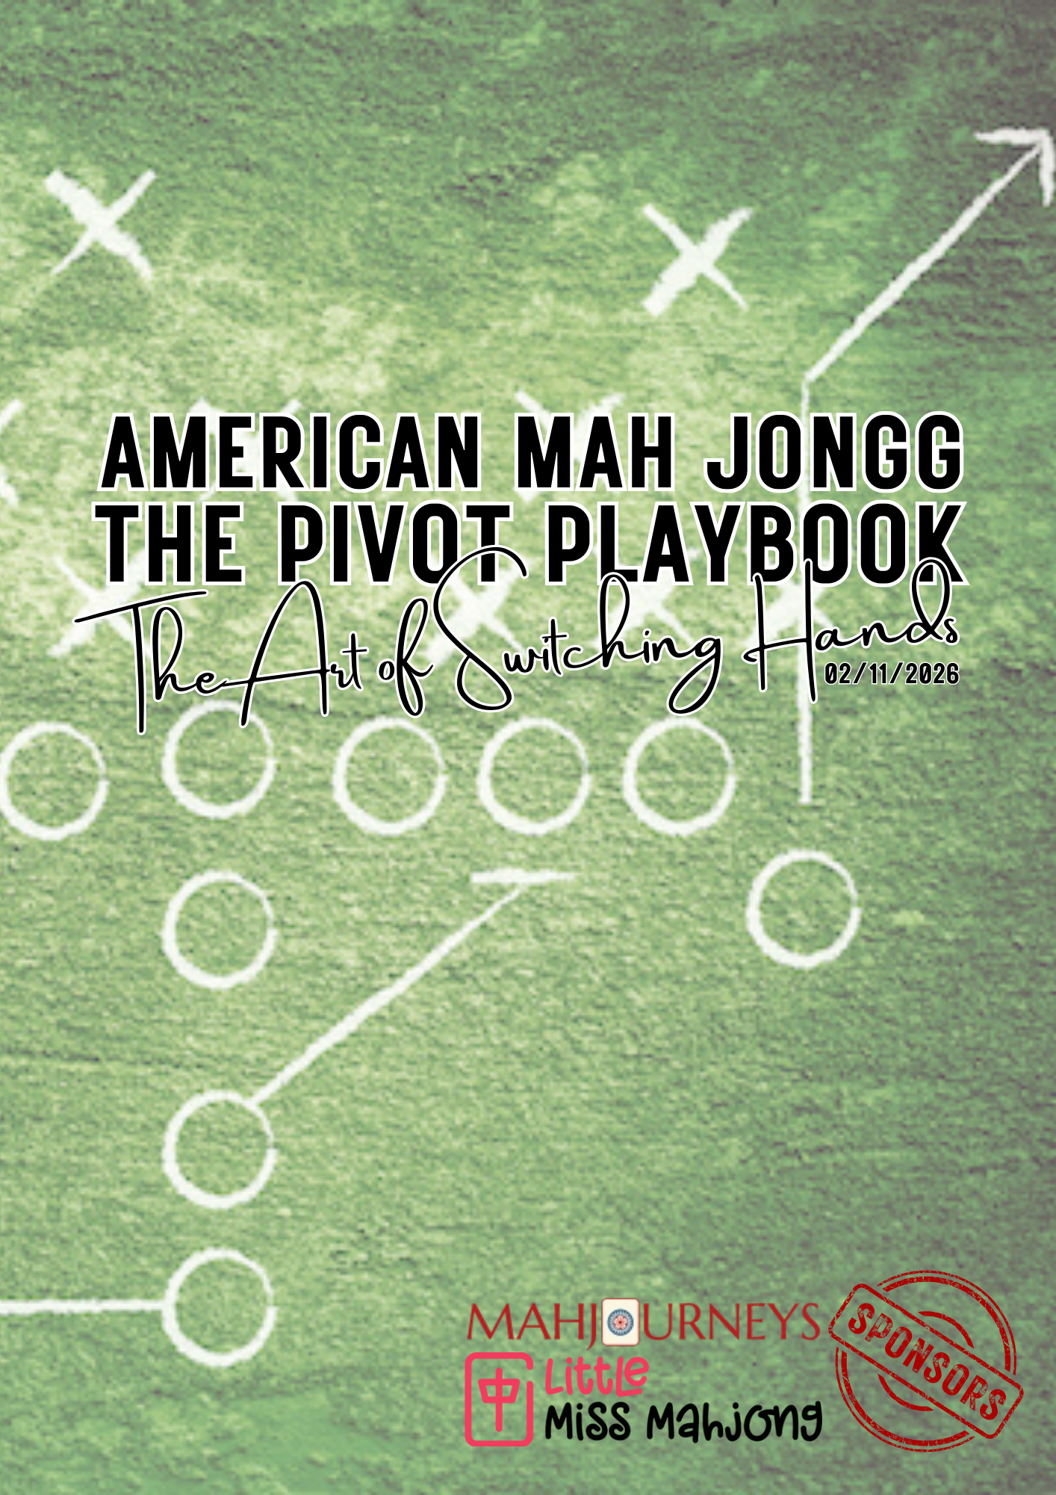

The Pivot Playbook
This workbook is intended to be used digitally. If you work better on print, enter space under prompts.

Pivot Insights
This worksheet is designed to help you capture key insights from the presentation and live demonstrations while they’re still fresh. There are no right or wrong answers. The goal is to notice what changed in your understanding of pivoting—and how that will shape your decisions going forward.
Before Today
What comes to mind when you hear about backup hands or switching hands?
I choose a backup hand early gave me flexibility
I choose a backup hand early gave me flexibility
I memorize overlapping hands on the card to keep my options open
I memorize overlapping hands on the card to keep my options open
I don’t get how it all works

Key Insights
During the demonstration or examples, what stood out to you most?
How quickly a strong hand can become vulnerable
The impact of discards and exposures on feasibility
Sharing common tiles does not guarantee switchability
Pivoting depends on what the table shows, not what the card suggests
Timing matters more than flexibility
Pivoting is a judgment call, not a pregame plan

Was there a specific moment when it became clear that a pivot was or was not feasible?
What You’ll Pay Attention To Going Forward
When considering a pivot in the future, what will you notice first (check all that apply)?
Tile dependencies
Discards and exposures
Wall depth and timing
Hand strength or vulnerability
Table position and opponent speed
One Habit You’ll Change
What is one habit, assumption, or pattern you plan to let go of?

Pivot Reflections
From Backup Hands to Pivot Judgment
This worksheet is designed to help you reflect on how your understanding of switching hands has evolved. There are no right or wrong answers. The goal is to capture what you noticed, what shifted, and what you’ll apply going forward.
Part 1: How I Used to Think About Backup Hands
Before this session, how did you understand the idea of a “backup hand”?
I believed choosing a backup hand early gave me flexibility later
I looked for overlap on the card to keep my options open
I felt safer knowing I had a Plan B in mind
I wasn’t sure how pivoting really worked
Other:
In your own words, describe how you approached backup hands before today:

Part 2: What I Noticed During the Demonstration
During the live demo or examples, what stood out to you most?
How quickly a hand can shift from strong to vulnerable
How often “backup” hands collapsed without warning
The role discards and exposures played in blocking options
The importance of wall depth and timing
Other:
What moment made it clear that a pivot was or was not feasible?

Part 3: The Breakthrough
Which statement best reflects your current understanding?
Backup hands don’t guarantee switchability
Pivoting depends on what the table shows, not what the card suggests
Timing matters more than overlap
Pivoting is a judgment call, not a pregame plan
Describe your biggest “aha” moment from this session:

Part 4: What I’ll Apply Going Forward
Going forward, what will you pay closer attention to when considering a pivot (check all that apply)?
Tile dependencies
Discards and exposures
Wall depth and timing milestones
Hand strength and vulnerability
Table position and opponent speed
Complete this sentence:
I will stop thinking about backup hands as plans and start thinking about pivoting as…

Part 5: One Thing I’ll Do Differently
What is one specific habit or thought pattern you plan to change at the table?

Pivoting isn’t about having more options — it’s about recognizing when the table requires a change. What does that mean to you now?

Reflections

The Pivot Challenge
The Pivot Challenge uses four deliberate pivot points to give players structured practice making pivot decisions under different conditions. Each point represents a common moment where players feel pressure to change course—and where judgment, not habit, should guide the decision.

Pivot Points & Why They Matter
Pivot Point 1 After the First Left in the Charleston
This point introduces early pivot thinking without commitment. Players practice recognizing when hand development stalls before too many tiles are invested. It helps students notice stagnation without reacting prematurely or chasing flexibility too soon.
Pivot Point 2 After the Charleston
A lackluster Charleston often triggers anxiety-driven pivoting. This checkpoint teaches players to evaluate what they actually gained—or failed to gain—before deciding whether a shift is warranted. It reinforces that a weak start does not automatically require a pivot.
Pivot Point 3 at ~70 Tiles Remaining (Pivot Sweet Spot)
This is the most reliable moment to practice real pivot judgment. Enough information is visible to assess feasibility, and there’s still sufficient wall depth to rebuild. This pivot point trains players to recognize when a pivot is both informed and possible.
Pivot Point 4 at ~50 Tiles Remaining
This point challenges players to confront late-game reality. Most pivots here fail—not because they’re wrong in theory, but because time has run out. Practicing at this stage teaches restraint, acceptance, and better push–fold judgment.

Options
The Pivot Challenge can be done two ways, both reinforcing the same judgment skills—the difference is pacing and cognitive load.
Option 1: Progressive Pivot Challenge
Each game focuses on one Pivot Point, allowing players to isolate the decision, reflect, and reset.
- Game 1 — Pivot Point 1: After the first left in the Charleston
Practice recognizing early stagnation without reacting prematurely.
- Game 2 — Pivot Point 2: After the Charleston
Practice evaluating a lackluster start without panic pivoting.
- Game 3 — Pivot Point 3: ~70 tiles remaining (pivot sweet spot)
Practice informed, feasible pivoting with sufficient wall depth.
- Game 4 — Pivot Point 4: ~50 tiles remaining
Practice restraint and late-game judgment when a hand is unwinnable.
You get repetition without overload. Each game reinforces a single lesson, making patterns easier to recognize and discuss during debrief.
Option 2: Hardcore Pivot Challenge
All four pivot points are evaluated within a single game. Pause briefly at each pivot point to assess:
- hand strength and position
- dependencies
- feasibility
- timing
This format mirrors real-game pressure and reveals how quickly feasibility shifts.
Revisiting the Pivot Challenge a few times a year helps you reset your judgment and sharpen your timing. It trains you to notice feasibility sooner, release assumptions, and make clearer decisions as the table shifts. This challenge is especially valuable before a competition, when pressure increases and habits tend to take over. Running it again reminds you to respond to what the tiles actually show, so your pivot decisions stay grounded in awareness rather than guesswork.

The Pivot Challenge Log
Instructions:
- Play a game of solitaire with your tiles at home or play a game online.  - Identify the strength of the hand (e.g., multiples, predominant pattern).  - Use the framework below to record your pivot decisions and rationale. |  | 
 | How to Pick a Hand | Skill Builders | How to Switch Hands

Phase | Hand Snapshot | Plan A | Plan B | Feasibility | Dependencies
Dealt Hand | J F 478 bam 12679 crak 4569 dot | CR 6789 of some kind  Predominant pattern, CR | Evens #4 or 8  Predominant Pattern | Wide open | 8 crak
After Round 1 | J F E 789 bam 24677 crak 269 dot | CR 6789 of some kind  Predominant pattern, multiple | Big Odds  Multiple | Wide open | 5 crak
After Round 2 | J F E 77 bam 56779 crak 8899 dot | CR 2-2 or CR #4  Predominant pattern, multiple | Big Odds  Multiple | Wide open | 5 crak
Observations | Between hands in one category; Underdog
Pivot Point 1 First Left of the Charleston
Phase | Hand Snapshot | Plan A | Plan B | Feasibility | Dependencies
Dealt Hand
After Round 1
Observations
Challenge:
- Document which categories/hands are feasible
- Document Plan A and Plan B. Play.
- Attempt a pivot after the first left.

Pivot Point 2 After the Charleston
Phase | Hand Snapshot | Plan A | Plan B | Feasibility | Dependencies
Dealt Hand
Before P&D
End Game
Observations
Challenge:
- Document which categories/hands are feasible.
- Document Plan A and Plan B. Play.
- Attempt a pivot after the Charleston
Pivot Point 3 at ~70 Tiles Remaining
Phase | Hand Snapshot | Plan A | Plan B | Feasibility | Dependencies
Dealt Hand
At 70 tiles
End Game
Observations
Challenge:
- Document which categories/hands are feasible.
- Document Plan A and Plan B. Play.
- Attempt a pivot at 70 tiles remaining
Pivot Point 4 at ~50 Tiles Remaining
Phase | Hand Snapshot | Plan A | Plan B | Feasibility | Dependencies
Dealt Hand
At 50 tiles
End Game
Observations
Challenge:
- Document which categories/hands are feasible.
- Document Plan A and Plan B. Play.
- Attempt a pivot at 50 tiles remaining
Reflections:
- How often did your “backup hand” survive the stage?

- Which dependencies blocked your pivot plan?

- How did timing affect your decisions?

- How did observing exposures and discards change your pivot strategy?

- What is your key takeaway from The Pivot Playbook?

