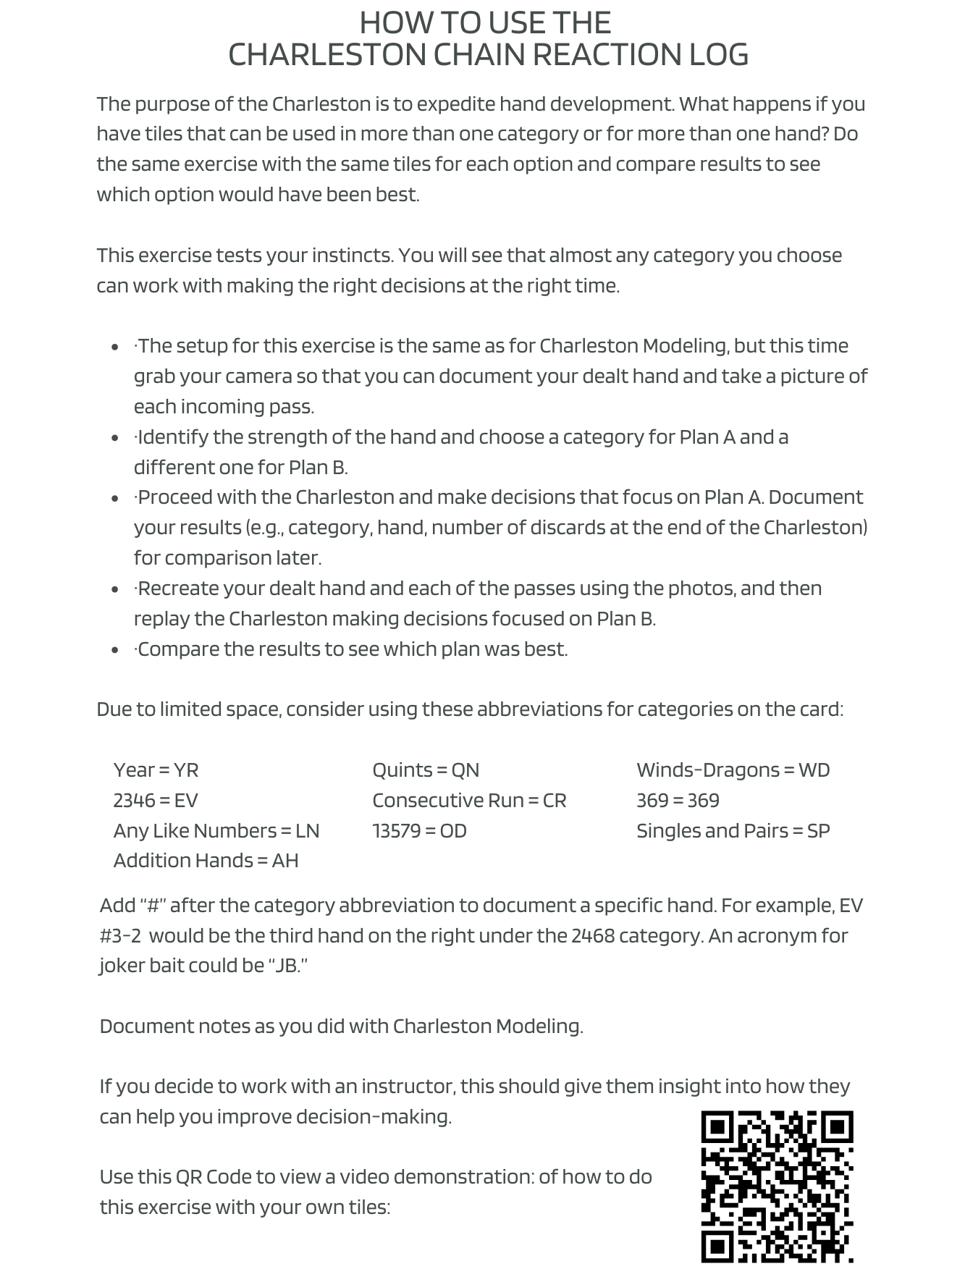
Charleston Chain Reaction Log

Charleston Modeling Log
Position Point Average

# |  | Category/Hand # | #Multiples | #Gaps | #Weaknesses | #Discards | Position Points
Plan A
Plan B
Dealt Hand
Outcome

# |  | Category/Hand # | #Multiples | #Gaps | #Weaknesses | #Discards | Position Points
Plan A
Plan B
Dealt Hand
Outcome

# |  | Category/Hand # | #Multiples | #Gaps | #Weaknesses | #Discards | Position Points
Plan A
Plan B
Dealt Hand
Outcome

