Contents

INTRODUCTION 2

ROLES AND RESPONSIBILITIES 4

MEMERSHIP DUES 4

POST AN EVENT 4

EDIT AN EVENT 9

PREPARE FOR AN EVENT 11

CANCEL AN EVENT 13

CONFLICT RESOLUTION 16

# INTRODUCTION

This document should contain all the information Meetup Officers and Organizers need to perform the daily activities necessary to run a successful Meetup.

As a member of the leadership team, you will have the freedom to run your events as you choose within the *Meetup Charter* and the guidelines expressed in this document.

If you have any questions, at any time, feel free to call Meetup Officers:

Name, Role

Mobile

Email

Manage your group and edit settings anytime:

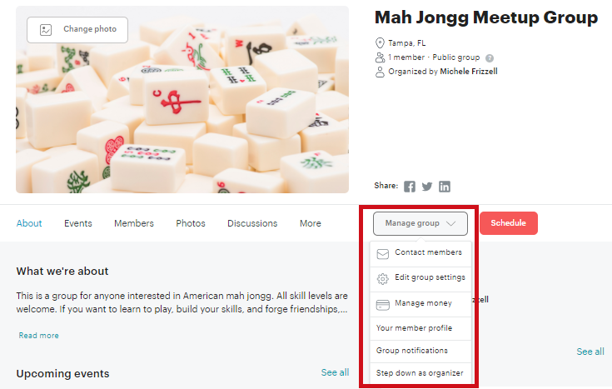

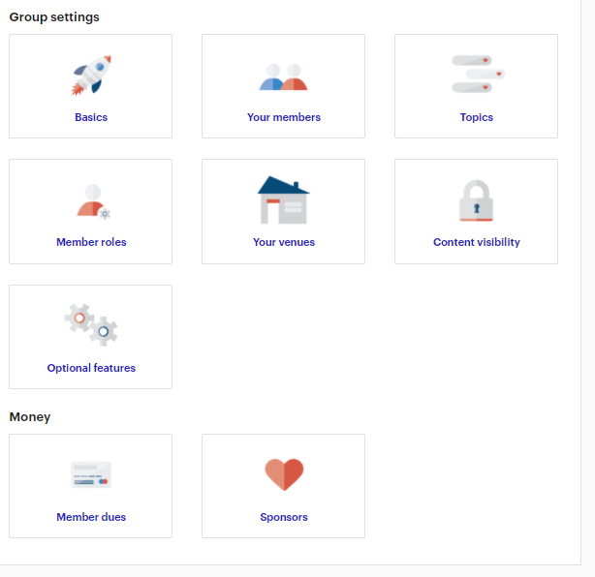

# ROLES AND RESPONSIBILITIES

Meetup Organizers have an essential role in fulfilling our mission to promote the game and culture of mah jongg. Following are the roles and responsibilities of our Meetup Organizers:

*Organizer and Co-Organizer*

The Organizer and Co-Organizer have full control over the Meetup Group, including the ability to manage the group calendar and site settings, all member communication, and everything related to money collection. The Co-Organizer role will be given to Meetup Officers and their responsibilities are in our *Meetup Charter*. Responsiblities include those listed for an Event Organizer.

*Event Organizer*

The Event Organizer has limited control over the Meetup Group, but has full control over the group calendar and can email members. For each event, Event Organizers will be expected to monitor RSVP's, reply to comments and send emails as needed. They will also need to collect dues from members and guests. They may add events to our Meetup Calendar as they wish but should adhere to event detail guidelines described in this document.

At our events you may be asked questions about our Meetup so Organizers should be able to share about our group with members, guests and venue patrons. Organizers should also be confident about the content of our Meetup site, they should know how to navigate through our site and they should be able to use the calendar tools. Be sure to study the *About Us* page and the *Meetup Charter*. Check these pages often because, like this document, they will always be a work-in-progress.

# MEMERSHIP DUES

We require all members to pay annual dues of $13.51 ($1.51 covers the payment system transaction fee). They are given a title of “Patron Member”.

New members are given a 14-day trial. They are given a title of “Trial Member”.

We allow members to bring guests. Encourage repeat guests and drop-ins to join our Meetup so that they can RSVP. Emphasize the importance of knowing who is coming and how many people are coming so that we can prepare in advance and make appropriate arrangements with venue staff.

# POST AN EVENT

To see a calendar view, click “See all”

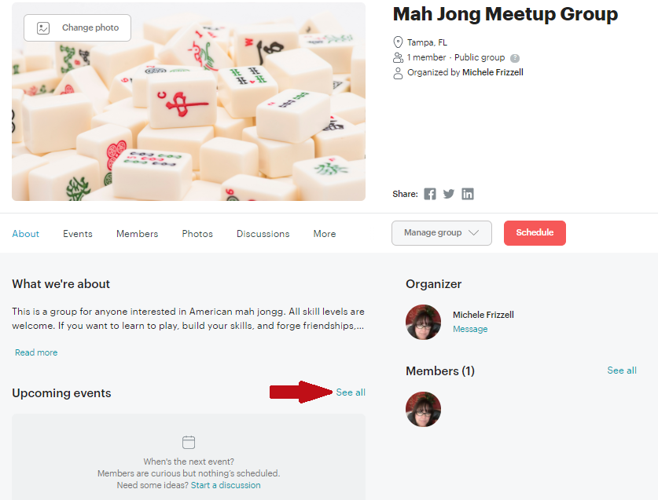

To post a new event, you need to be on the “Calendar” page, hover your mouse over a date in the calendar, then click the “add” icon.

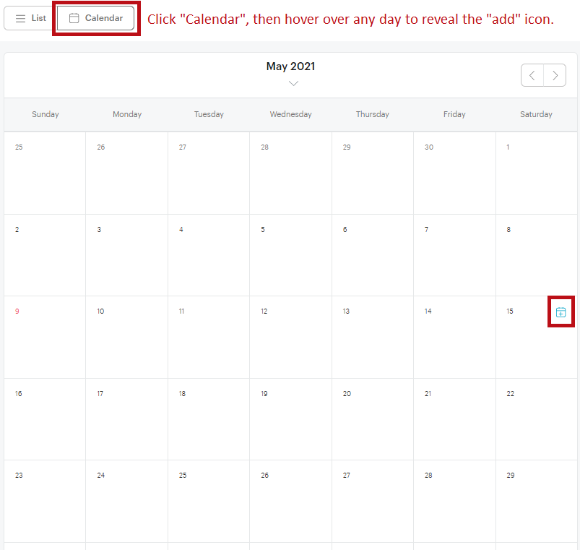

Follow the steps provided in the event form using these guidelines:

Research has shown that people do not “read” on the web, they skim and scan.  They spend 80% of their time above the fold (content visible upon opening of a webpage) and only 20% of their time scrolling to see the rest of the content. Therefore, follow these guidelines when posting events for our Meetup:

Title

* If the event is for **all skill levels**, the title should follow this convention, “City Mah Jongg – Skill Level”
* If the event is for a **specific skill level**, the title should follow this convention, “City Mah Jongg – Style Skill Level”
* Skill level should be one of the following:  Open Play, Experienced, Advanced to fit our *Meetup Charter* descriptions:

Members who have never played mah jongg before must have had at least one lesson prior to playing at any event. **Lessons** are available on the calendar and instructors are available to teach at **Learn and Play** events.

Members who know the basics of the game but want to improve their game should look for **Open Play** events where beginner and intermediate players hone their skills with experienced players nearby to help when needed. Members who are experienced players are welcome to come to **Open Play** events but should expect to play at a slower pace and stop to help beginners when asked.

Members who are well versed with the game and enjoy a social style of playing should look for **Experienced** events. Members who have had at least one lesson and are comfortable playing independently are also welcome to attend.

Members who want to play hard and fast should look for **Advanced** events. Again, we are a very social group so even though games are played at a fast pace there will still be table-talk. If you prefer a serious, no-frills game this may not be the group for you.

Details

* Every event should start with this disclaimer:

“Many people know about mah jongg through the solitaire game online where the player selects pairs of mah jongg tiles. This is a solitaire game, but it is NOT mah jongg!  If you have never played the 4-player game, you must attend a lesson prior to playing at any of our events.  Look for **Lessons** or **Learn & Play** events on our calendar to sign up.”

* Use bullets to break up paragraphs
* Keep content above the fold whenever possible

Example for an event welcome players of any level:

Title:  Canton Mah Jongg – NMJL Open Play

We will start playing as soon as we have enough players. We'll order lunch and eat 'n play or break to eat when the food arrives. Abbotts Bar & Grill has graciously allowed us to frequent their venue free of charge. Please plan to purchase a meal and tip generously to show our appreciation.  
  
We will be playing National Mah Jongg League (NMJL) style with a $5 pie (quarters, nickles, dimes). Whenever possible, we arrange for the ideal 4-player table. Since some members drop-in or drop-out at the last minute, all members should be prepared to play at a table of 3 (Charleston, dealer's choice), 4, or 5. We will always have a player rotation to ensure an enjoyable experience for everyone.  
  
We have found that, though we love playing the game, the real fulfillment comes from being with good friends. All skill levels are welcome. We are a very social group so you will find that our events are filled not only with great mah jongg but with laughter and lively conversation as well. If you prefer a serious, fast-paced game this may not be the group for you.  
  
Always read event details before you leave for the game to make sure nothing has changed that would affect your plans to attend.  
  
4 PLAYER MINIMUM. 16 PLAYER MAXIMUM.

Check the attendee list before coming to be sure that there are enough players!

Example for an event welcome players of a specific:

Title:  Canton Mah Jongg – NMJL Advanced Play

Many people know about mah jongg through the solitaire game online where the player selects pairs of Mah jongg tiles. This is a solitaire game, but it is NOT mah jongg!  If you have never played the 4-player game, you must attend a lesson prior to playing at any of our events.  Look for **Lessons** or **Learn & Play** events on our calendar to sign up.”

We will be playing American/NMJL style mah jongg.  This event is for players who are well versed with the game.  If you have had a lesson and are comfortable playing independently you are welcome to come and play.

Dutch-Style Dinner:  5:00 PM - 6:00 PM

Play:  6:00 PM - Close

4 PLAYER MINIMUM PER STYLE

Check the RSVPs before coming to be sure that there are enough players!

# EDIT AN EVENT

To make changes to an event that is already been posted on the calendar, open the event, then click the “Organizer tools.”

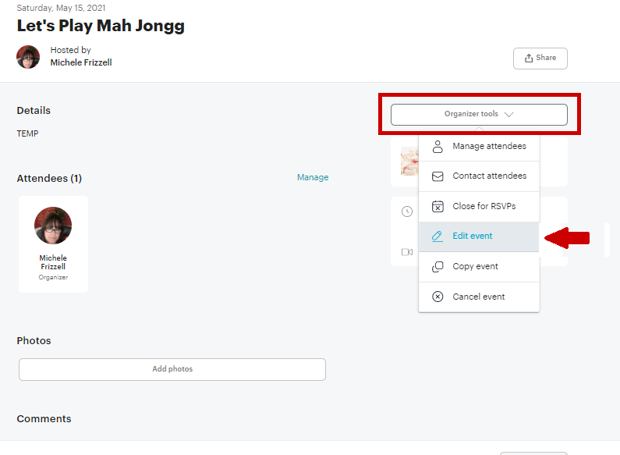

The event form will open in edit mode so you can make changes as needed. If the event is part of a series, you will need to choose if you want to change only one meetup or all that follow. Click the “Edit” button when you are ready to edit the event.

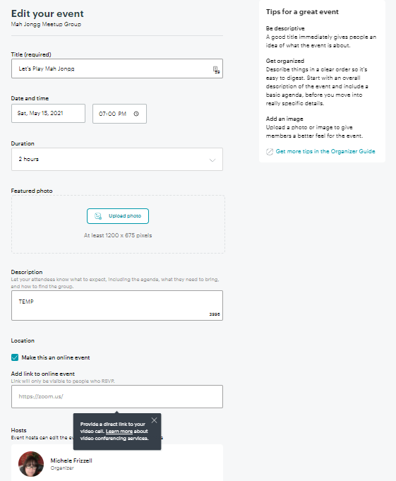

# PREPARE FOR AN EVENT

Monitor your event often because members will post comments and questions that may need a response.

You can email members in your RSVP list through the “Tools” drop down. This is handy if you have to make any changes to your event like RSVP status, location or start time. You can also email individual members through their profile.

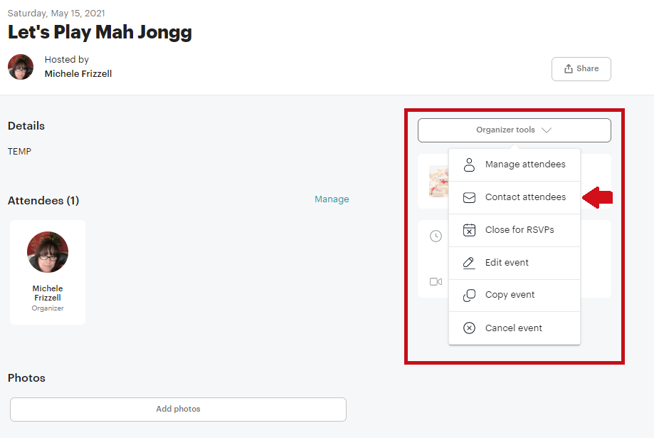

At your event, if someone decides to join, write the amount that they paid next to their name on Attendee List. If a drop-in pays, just add their name on the Attendee List and include the amount they paid next to their name. At the end of the event, place the Attendee List and money in an envelope. Deliver all Attendee Lists and money to the Meetup President for processing.

We recommend that you buy an expandable file to hold everything you need at your event. Include contact cards and receipt book.



# CANCEL AN EVENT

You will need to cancel an event if you do not have enough members committed to coming.

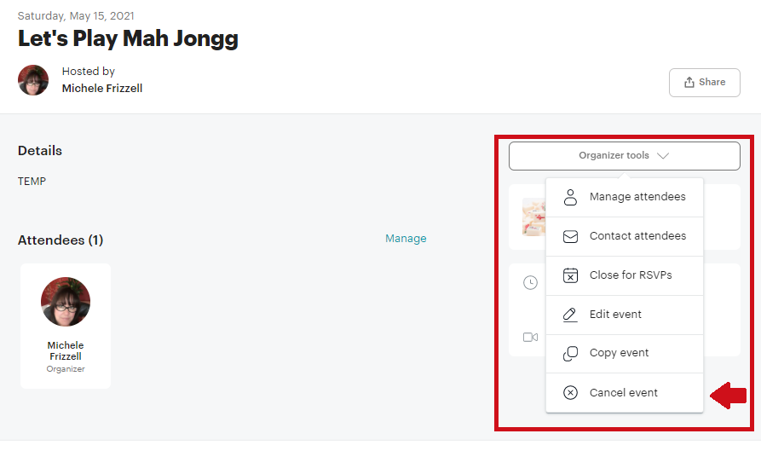

After you click “Cancel”, select “Delete this Meetup from the calendar.

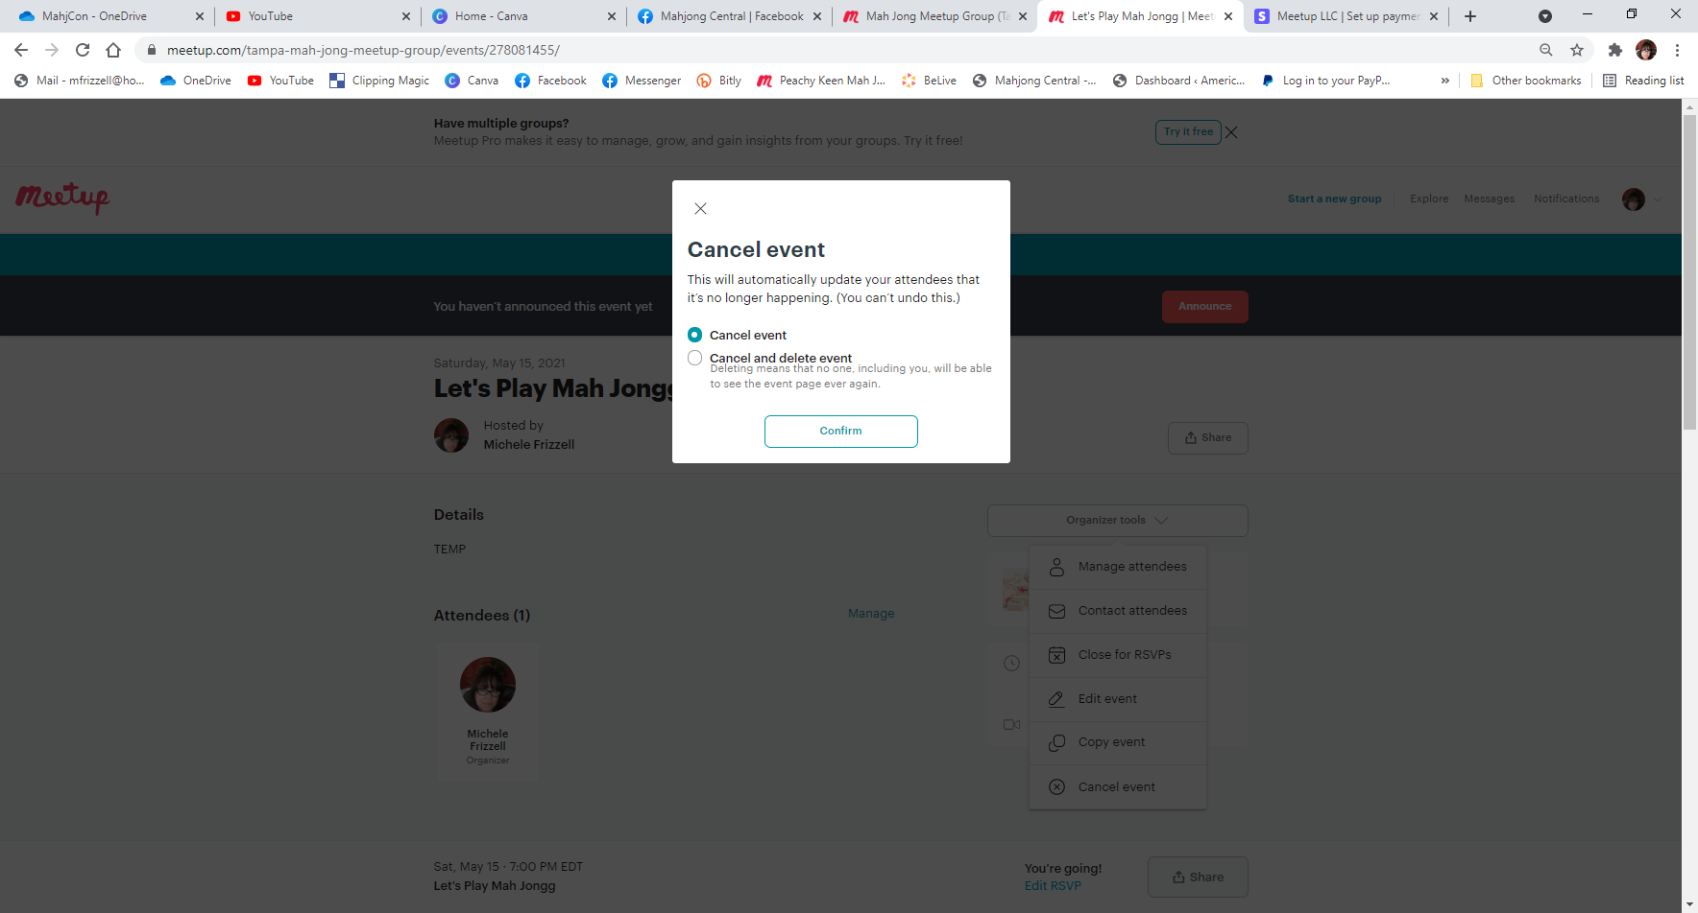

If it is a recurring event, you will be prompted to choose which events to cancel – regardless, always select the “Remove from calendar” option. Once you confirm the cancellation, click the “Email Members” button in the top right corner so that you can announce the cancellation to members who RSVP’d.

When the email form appears, leave defaults as-is except modify the message to explain the reason for the cancellation, then click “Submit”. Here is an example:

Let’s Play Mah Jongg, scheduled to occur on Friday, May 15, 2021 at 11:00 AM has been cancelled because we did not have enough players. Please udpate your plans accordingly.

If you have further questions, you can email the team throught eh Conact us link onMeetup.

# CONFLICT RESOLUTION

Invariably you will witness or experience interpersonal conflicts. We recommend that you confront bad behavior immediately. We have a "3 strikes and you're out" policy so keep track of your attempts at conflict resolution. If issues persist after two interventions, contact a Meetup Officer and explain the issues. They will then continue the process from that point.

Here is the Disciplinary Action section of our *Meetup Charter* that all members should be aware of:

To protect our purpose and mission we have established a "3 strikes and you're out" policy. We expect all of our members to follow the universal golden rule, "One should treat others as one would like others to treat oneself". In terms of game-play, this means...

Do …

* + Be hospitable – welcome new arrivals and get to know new members
  + Be courteous – pay attention to the winner, then kvetch
  + Be cordial – play nicely with players who are not in your close circle of friends
  + Be gracious – play patiently with new players, remember we all started at the same place and needed others to teach us how to play

Don't …

* + Be critical – gentle instruction is welcome, critical remarks are not
  + Be negative – bad days are had by all but, by the same token, a fun time is expected by all so keep it light hearted; make every effort to exhibit good sportsmanship; also, if you want to have a serious conversation, take it to the side
  + Be disparaging of others – kindly deal with issues as they happen - if an issue is not resolving, take it one-on-one. If an issue is still not resolving after a one-on-one, discreetly take it to your event leader. If an issue persists even after discussing it with your event leader, take it to a Meetup Officer.