**Meetup Framework**

Contents

Introduction 2

Registration 2

Customization 2

Group Settings 2

Basics 3

Your Members 3

Topics 3

Member Roles 3

Your Venues 4

Content Visibility 4

Optional Features 4

Money 4

Group Notifications 5

# Introduction

Meetup is an online platform with event management tools for Individuals who share similar interests. The purpose of running a meetup is to organize events where members connect with each other.

Organizers can schedule events, create rules of engagement members should abide by, manage members, and manage event RSVPs. By following best practices, a meetup group will allow you to build your brand and establish yourself as an authority in your niche.

# Registration

Follow the prompts in this framework to prepare content for your Meetup.

Where’s your new Meetup Group’s Home Town (city, ST)?

|  |
| --- |
|  |

What will your Meetup be about (i.e., keywords)?

|  |
| --- |
|  |

What will your Meetup’s name be?

|  |
| --- |
|  |

Describe who should join, and what your Meetup will do (must be at least 50 characters).

|  |
| --- |
| This is a group for anyone interested in American mah jongg. All skill levels are welcome. If you want to learn to play, build your skills, and forge friendships, this group is for you! |

What it means to be a Meetup (agreement required to continue)

* Real, in-person conversations
* Open and honest intentions
* Always safe and respectful
* Put your members first

We review all Meetups based on our [Community Guidelines](https://meetup.zendesk.com/hc/sections/360000683791-Community-Guidelines).

After “Agree and Continue” is clicked, your Meetup will get a quick review before it's live. This typically happens within 24 hours, and you'll get an email as soon as it's approved. After approval, your new Meetup will be shared with the community. In the meantime, you can continue with customization.

# Customization

Write a short Meetup bio.

|  |
| --- |
|  |

Write a welcome email for new members.

|  |
| --- |
|  |

Find a photo and write a caption (40 character limitation).

|  |
| --- |
|  |

## Group Settings

### Basics

This is where you can edit your Meetup name and update the description.

What do you call the members of this group? This is used in certain emails and areas of Meetup. (Examples: Runners, New Moms, Bookworms)

|  |
| --- |
|  |

Enter the zip code for your Meetup (may or may not be where you live).

Create a custom Meetup URL (i.e., no spaces, use dashes).

|  |
| --- |
| meetup.com/text-separated-by-dashes |

You can also upload a Meetup logo and change your Meetup photo.

### Your Members

You have the following options for member onboarding:

* New Member approval
  + Organizer must approve
* When a member joins
  + Require a photo
  + Profile questions

Welcome message to new members.

|  |
| --- |
|  |

We highly recommend all the above.

### Topics

Choose topics to categorize and describe what your Meetup Group is about in a word or two. Pick up to 15 topics for your Meetup Group.

### Member Roles

Plan how you want to build your leadership team.

* Organizer: The Organizer has full control over the Meetup Group, including the ability to manage the group calendar and site settings, all member communication, and everything related to money collection.
* Co-Organizer: The Co-Organizer can do everything the Organizer can do, with the exception of receiving online payments.
* Assistant Organizer: The Assistant Organizer can manage the group calendar and all member communication but isn't able to manage most site settings or any money collection.
* Event Organizer: The Event Organizer has limited control over the Meetup Group but has full control over the group calendar and can email members.

Decide who can create new pages in your Meetup.

### Your Venues

Gather venue names, address, and phone number to list where your events will take place.

### Content Visibility

Decide what type of Meetup you want to run:

* Public: This group’s content, including its members and event details, is visible to the public.
* Private: Only members of this group can see its full content, including details about its members and events. Some information about the group is public. These basic details about groups and events are always public, regardless of your content visibility setting:
  + Basic group information: group name, main photo, description, number of members, group reviews, date founded
  + Basic organizer details: organizer name and profile photo
  + Basic event details: titles, date, time, and number of attendee RSVPs

### Optional Features

This is where you can further customize your Meetup:

* Communication (i.e., mailing list, message board)
* Currency
* Social Media

## Money

If you decided to charge member dues, you will need a “stripe” account. You will also need to provide the following information:

* Legal name
* Email address
* Date of Birth
* Home address
* Phone number
* Last 4 digits of your Social Security Number
* Business Details
  + Industry
  + Website
* Payout Details (i.e., bank account or debit card)

Choose how to communicate what member dues covers. We highly recommend the following:

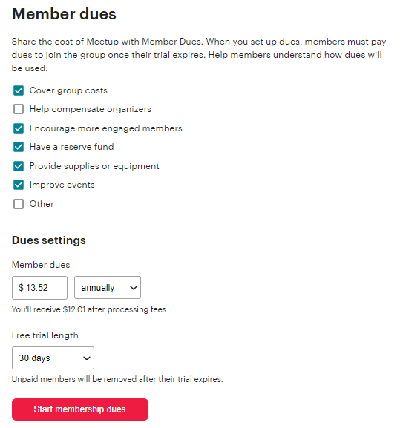

## Group Notifications

Toggle notifications on or off to notify of Meetup activity.